What you need:
Flax or Palm Leaves (1 per flower)
Nylon (Nylon is my preferred option . However, I used a thin bead thread so it would show up in the photos)
Little beads or shells. I used Paua shell.
Scissors
Needle
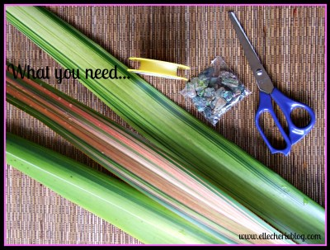

Step 1
Split the flax in half (from the sharp point down) but leave about 15 cm still joined (leave longer if you want a longer stem)
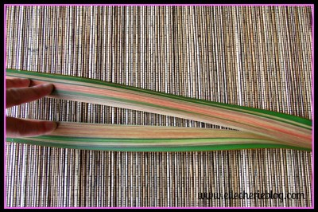

Step 2
Lie the flax flat on a table and start by crossing the left leaf under the right one. Then fold that now left one back under the right one.
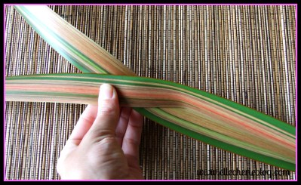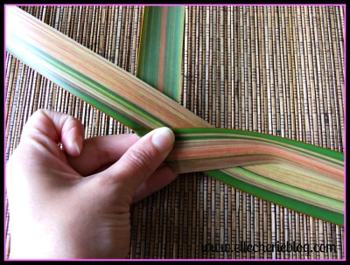

Step 3
Then continue to fold the one that’s now on the left under the right one, and you are going to keep doing this same pattern until you get to the end. So, to recap always fold the one that is on the left under the one that’s on the right.
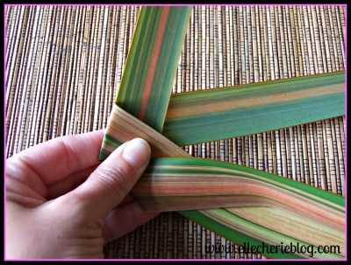
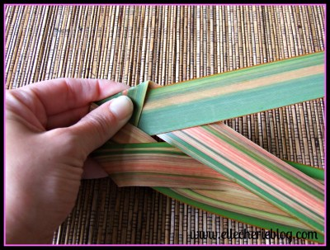
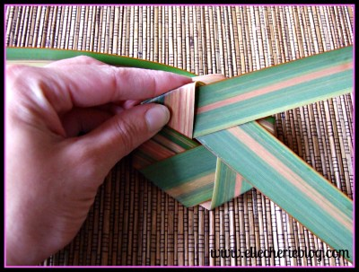
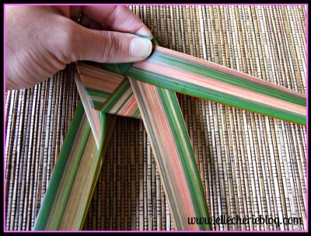
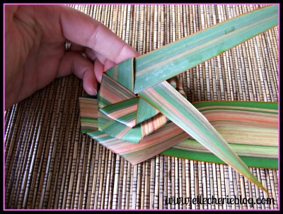

Step 4
Eventually, you will get to the end of the leaf and because of the way the folds work it ends up in the shape of a flower.

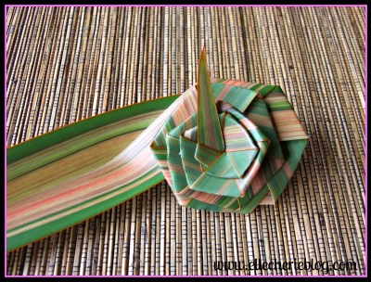

Step 5
Pull it around in a circle quite tight so that it almost looks like a rose. Then you want to get your pieces of shell or paua, needle and nylon.

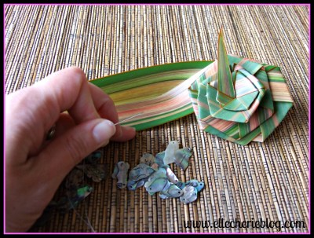

Step 6
Thread through the leaf and then through your shell or bead. Thread back to the backside of the flower and then to the front again and continuing to the back again – knot it off.
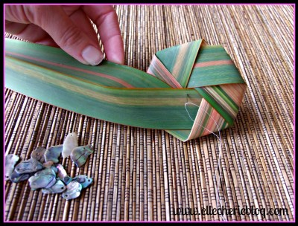
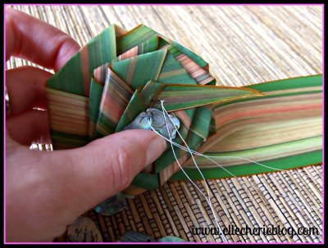
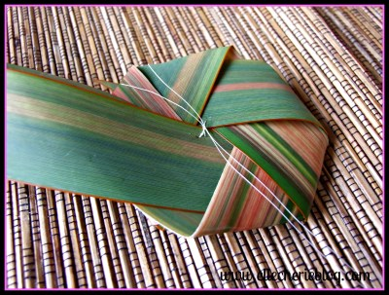
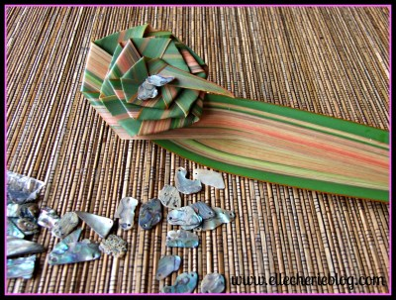

Step 7
The next image shows two extras flowers that I have made up. As mentioned earlier these can make a neat little gift as you can pop them in a box and post them – could be a great gift idea for the grandparents!
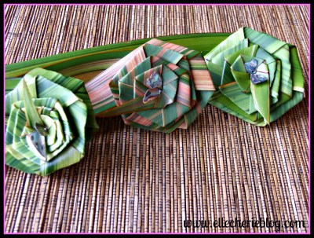
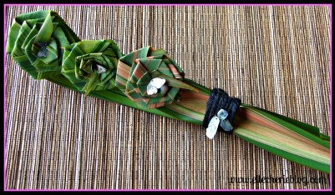
And that’s it! I find that it does take a bit of time to get used to the folding of the Flax but after a few goes you can whip them up in no time.
Did you have a go at making these? how did you get on?
Don’t forget to save this post to your DIY board on Pinterest!
