Māori protocol
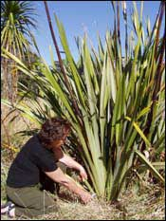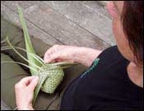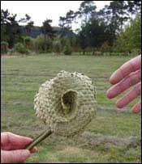
The weaving of flax follows a long and rich tradition established by Māori, the indigenous people of New Zealand. Māori tradition includes a protocol, or tikanga, that covers both harvesting and weaving flax. I’m not able to speak on behalf of this tradition, as I have no Māori ancestry, but I think it’s important to respect the protocol. This protocol can vary slightly in different parts of the country but here is my understanding of the most widely accepted protocol:-
Before harvesting the flax, a prayer of thanks may be said. When harvesting flax, the central shoot of each fan of leaves, or rito, is not cut, nor are the two leaves, the awhi rito, on either side (see instructions and photo further down on this page). The outer leaves are cut in a downward motion as close to the base of the leaf as possible. (This will keep the flax plant healthy and it will keep growing, so that it can be harvested again.) Flax is not cut at night or in the rain or snow and only enough flax is cut to complete the weaving project. Traditionally, flax is not cut by women who are menstruating, but I understand that — in light of changing views on women's health — this protocol is no longer observed by everyone. The cut flax is not stepped on or over and food and drink are kept away from the weaving area. Hands are washed after weaving and before eating. (If you don’t, you’ll soon learn that even a small quantity of the sap from freshly-harvested flax is highly laxative!) When the weaving is finished, discarded pieces of flax are not burnt but returned to the ground to rot. Traditionally it was returned to the ground underneath the flax plant it was cut from, but now it is often recommended that waste flax is returned to the ground some way from the flax plants to avoid setting up conditions conducive to disease. Weaving projects that have been started are finished and the first weaving project a person completes is given away.

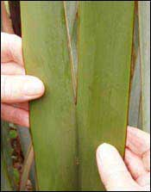

Selecting the leaves
As it is often difficult to know which variety of Phormium tenaxyou are cutting, and therefore what uses it is best suited for, you will need to select the leaves with the characteristics required for your weaving project.
Softer, thinner leaves with a shorter useable weaving strip, up to about 50cm in length, are good for smaller items. Larger items require thicker, stronger leaves and longer strips, although the leaves should still be soft enough to weave with.
If your weaving project starts with a fibre plait where all the new strips are added one by one by plaiting in the fibre end on the strip, then the leaves will need to have a long fibre length. To check for length of fibre in the leaf, use the technique for making fibre ends described in the Preparing flax page.
Finally, check that the leaves are not damaged by pests and diseases as you cut.

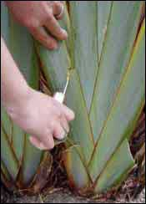

Cutting the flax
The leaves on the flax plant grow in separate fans with 2-14 leaves fanning out from a central new leaf. Leave this central leaf and the leaf each side of it so that the flax plant can keep growing. Cut the leaves on either side of these three central leaves, in a downward angle, away from the plant, and as close to the base of the leaf as possible. In this way, water can’t run into the centre of the plant and rot it.
When you have cut the leaves for your project, tie them together in bundles, keeping the leaves from each bush together. If possible, it's best to use leaves from the same bush in one piece of weaving. Before leaving, cut away any dead or diseased leaves from the plant to encourage new growth and to help keep the plant healthy.

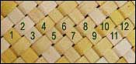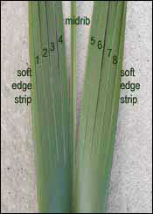

How many leaves to cut
To work out how many leaves to cut, first decide on the width of the weaving strips and how large the item will be that you are weaving. Smaller items look better in strips with smaller widths, such as half a centimetre to one centimetre, and larger items can be made with greater widths, up to one and a half centimetres wide.
Next decide how many strips the majority of leaves on your flax plant will provide, and determine the number of leaves to be cut by dividing the number of strips each leaf will provide into the number of strips required for the article, allowing a few extra leaves for good measure.

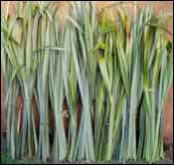

Storing the cut flax
Flax can be woven immediately, stored for two to three weeks before weaving, or boiled for long-term storage. It’s best to weave flax when it is neither too wet nor too dry. If it is too wet, it will shrink after weaving and leave gaps between the strips. For some weaving effects you may want gaps between the strips, but in most cases you will want a close weave, so that the woven item retains its shape in use. If the flax is too dry, it will be hard to weave and is likely to crack.
In the height of summer, cut flax will only keep a few days at the most until it becomes too dry to weave with. In winter flax will keep for several weeks after being cut as the moisture in both the flax and the surrounding atmosphere is usually high.
Store unboiled flax standing upright in a cool place. If the flax is to be kept for more than a few days, lay it flat and cover it with a tarpaulin to slow down the drying process.

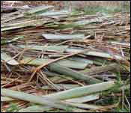

Disposing of flax scraps
When weaving is completed the discarded pieces can be returned to the ground to compost. Composting takes a long time and it’s best to keep the discarded flax well out of the way of lawnmowers. Traditionally the flax scraps were returned to the ground by the bush they were cut from. A more recent trend is to compost the flax scraps in a place away from the flax bushes to avoid the spread of pests and diseases.back to top

© Alison Marion Brown 2006. Last updated 11 July 2011.

